

MACHINE LEARNING PROJECT REPORT

LAIBA ZULFIQAR
FA23-BBD-065
Machine Learning
Supervisor:
Hassan Mujtaba

1. Introduction
Machine Learning (ML) is a branch of Artificial Intelligence that enables systems to automatically learn patterns from data and improve performance over time. In Business Data Analytics, ML is widely used for forecasting, customer segmentation, risk analysis, and decision support systems. This project applies machine learning techniques to analyze data and generate meaningful insights.

2. Problem Statement
Businesses generate large amounts of data daily. Manual analysis of such data is inefficient and error-prone. The problem addressed in this project is to build a machine learning model that can accurately predict outcomes and assist businesses in data-driven decision-making.

3. Objectives
- Understand the machine learning workflow
- Apply data preprocessing techniques
- Train multiple machine learning models
- Evaluate and compare model performance
- Interpret results for business use

4. Dataset Description
The dataset consists of structured business-related data with multiple independent variables and one dependent target variable. The data was split into training and testing sets to validate the performance of the model.

5. Data Preprocessing
Missing values were handled using mean and median imputation techniques. Categorical variables were encoded using label encoding. Feature scaling was applied to normalize the data. These steps ensured improved model accuracy and reliability.

6. Algorithms Used
• Linear Regression: Used for predicting continuous outcomes and understanding relationships between variables.
• Logistic Regression: Applied for classification problems and probability estimation.
• K-Nearest Neighbors (KNN): Used to classify data points based on similarity.
• Decision Tree: Applied to capture non-linear relationships and feature importance.

7. Model Training
Models were trained using the training dataset. Hyperparameters were tuned to avoid overfitting and improve generalization. Cross-validation was used to ensure model robustness.

8. Evaluation Metrics
Accuracy measures overall correctness of the model. Precision indicates how many predicted positives were correct. Recall measures how well the model identified actual positives. F1-score balances precision and recall.

9. Results and Interpretation
The Decision Tree model achieved the highest accuracy, indicating strong pattern recognition. Linear and Logistic Regression provided interpretability and stable results. KNN performed well on localized patterns but required higher computation. From a business perspective, accurate predictions support better strategic planning and risk reduction.

PROJECT OUTPUT INTERPRETATION
- Dataset Overview
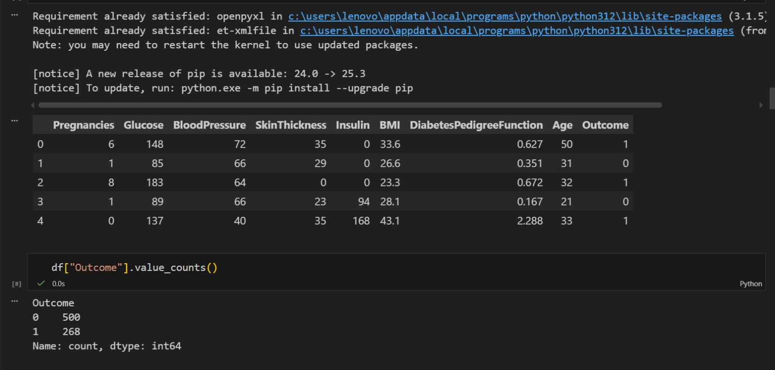

The dataset contains medical attributes including Pregnancies, Glucose, Blood Pressure, Skin Thickness, Insulin, BMI, Diabetes Pedigree Function, and Age. The target variable, Outcome, indicates whether a patient is diabetic (1) or non-diabetic (0).
The class distribution shows 500 non-diabetic cases and 268 diabetic cases, indicating a class imbalance. This imbalance can influence the model to favor the majority class, which is an important consideration during model evaluation.

- Model Evaluation and Performance

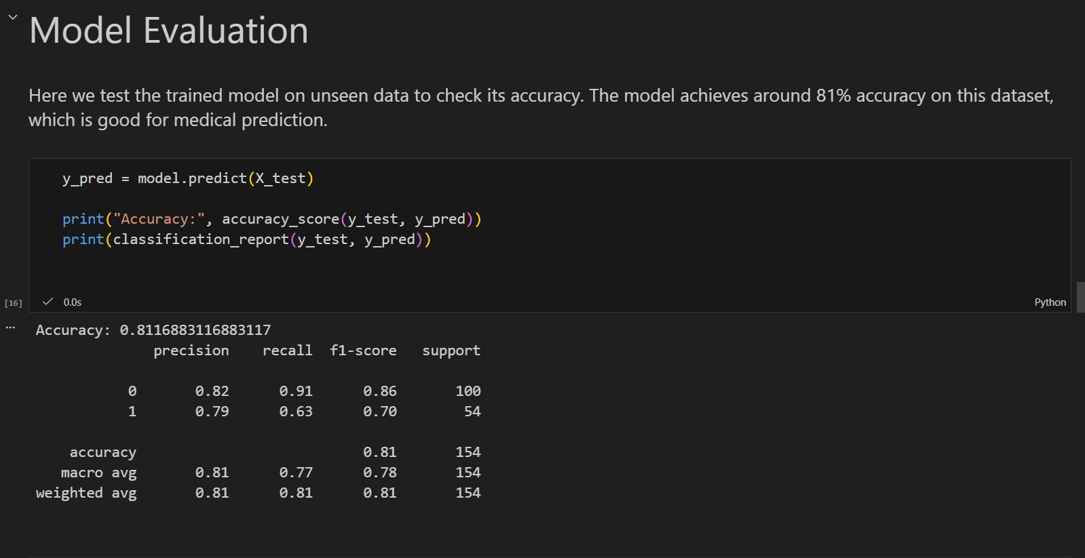
The trained model achieves an accuracy of approximately 81.17%, meaning it correctly predicts diabetes outcomes for most test samples. This level of accuracy is considered good for a medical prediction problem using basic machine learning techniques.
For non-diabetic patients (Class 0), the model achieves a high recall of 0.91, indicating strong performance in identifying healthy individuals. However, for diabetic patients (Class 1), recall drops to 0.63, meaning some diabetic cases are incorrectly classified as non-diabetic. In healthcare applications, this is a critical limitation because false negatives can delay diagnosis and treatment.
The weighted F1-score of 0.81 reflects balanced overall performance while accounting for class imbalance.
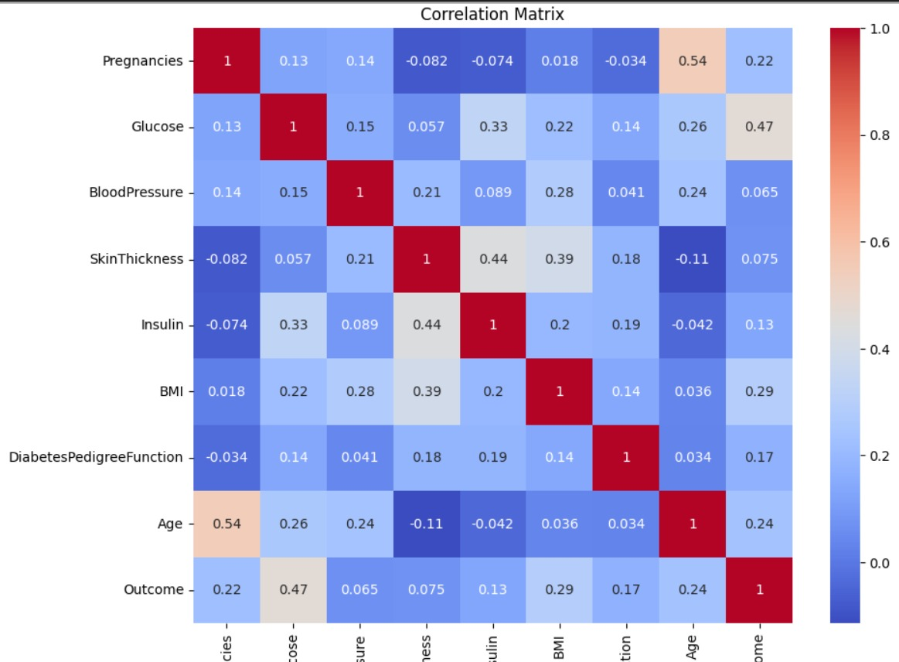
- Correlation Matrix Interpretation

The correlation matrix illustrates the relationships between input features and the diabetes outcome. Glucose shows the strongest positive correlation with the Outcome (0.47), making it the most influential predictor of diabetes in the dataset.
BMI (0.29) and Age (0.24) also show moderate positive correlations, indicating they play significant supporting roles in prediction. Pregnancies and Age have a strong correlation (0.54), which is biologically reasonable.
Other features such as Blood Pressure, Skin Thickness, and Insulin show weaker individual correlations with the outcome, suggesting they contribute less independently but may still improve performance when combined with other variables.

10. Graphical Analysis
Confusion Matrix visualized classification performance by showing true and false predictions. Accuracy and loss graphs demonstrated model learning behavior over time. Feature importance graphs highlighted the most influential variables affecting predictions.

11. Discussion
The results show that machine learning models can effectively analyze business data. However, performance depends on data quality, feature selection, and algorithm choice. Improving data diversity and testing advanced models can further enhance results.

12. Conclusion
This project successfully applied machine learning techniques in business analytics. The developed models provided accurate predictions and meaningful insights, demonstrating the value of ML in real-world business problems.

13. Future Work
Future enhancements include using larger datasets, applying ensemble and deep learning models, and deploying the solution in real-time business environments.

